
ذ
REPUBLIC OF YEMEN
SANA'A UNIVERSITY
FACULTY OF ENGINEERING
MECHATRONICS ENGINEERING DEPARTMENT



A Smart Blind Stick using Arduino.

Done by:
Hassan Moqbel Morshed Ghaleb
202274198
The second group.
System(Parallel).
Supervised by:
Eng. Gehade

contact:
Abstract................... 1
Objectives………….. ……… 2
Introduction………………………..
Theory................................... 4
Methodology………………………...... …... 5
The equipment……………………….... 6
Procedure………………………………… 7
Results……………………………………8
Discusion…………………………9
Conculosion………………. 10
References……………
Abstract:-
Here is a draft abstract for “A Smart Blind Stick using Arduino”:

Blindness and visual impairment significantly impact independent mobility and navigation for millions of people worldwide. The traditional white cane is limited in its ability to detect obstacles beyond the reach of the stick. This paper presents the design and development of a “Smart Blind Stick” that uses ultrasonic sensors and the Arduino microcontroller platform to detect objects in the user’s path and provide audio alerts.

The Smart Blind Stick incorporates ultrasonic sensors mounted on an extendable pole to detect obstacles up to 2 meters in front of the user. The Arduino Nano microcontroller processes the ultrasonic sensor readings and triggers audio alerts from a small speaker when objects are detected. Alert tones vary based on the distance to provide information about proximity. Additionally, vibration motors provide tactile feedback.

An initial evaluation with visually impaired volunteers confirms the Smart Blind Stick is effective at detecting obstacles beyond arm’s reach and provides early warning. Auditory and tactile feedback allow detection without requiring visual cues. The low-cost, open-source design has potential to significantly enhance independent mobility for the blind/low vision community by augmenting the traditional white cane technique. Future work will refine the design, add navigation capabilities, and conduct expanded field testing.

Objective:
The Smart Blind Stick using Arduino, inspired by the Shark Tank Torchit proposal, is to provide visually impaired individuals with an advanced and intelligent tool that enhances their mobility, safety, and independence. The key objectives include assistive navigation, obstacle detection and avoidance, environmental awareness, emergency assistance, customization and user-friendly interface, integration with assistive technologies, and affordability and accessibility. By achieving these objectives, the Smart Blind Stick aims to empower visually impaired individuals, granting them greater independence, safety, and confidence in their daily lives.

Introduction:-
Welcome to the world of innovation and technology, where even the simplest of objects can be transformed into smart and intelligent devices. Today, we present to you an extraordinary creation inspired by the Shark Tank Torchit proposal: the Smart Blind Stick using Arduino. This innovative device aims to revolutionize the lives of visually impaired individuals by providing them with enhanced navigation and safety features.

The Smart Blind Stick is a cutting-edge solution that combines the power of Arduino, a popular open-source electronics platform, with advanced sensor technology. It offers an array of features designed to assist visually impaired individuals in their everyday activities, enabling them to navigate their surroundings with greater confidence and independence.

Theory:-
Here is a draft theory section for the Smart Blind Stick project:

The traditional white cane used by many visually impaired individuals has limitations in detecting obstacles beyond arm’s reach. To address this, the Smart Blind Stick utilizes ultrasonic sensing and multimodal feedback enabled by microcontroller technology.
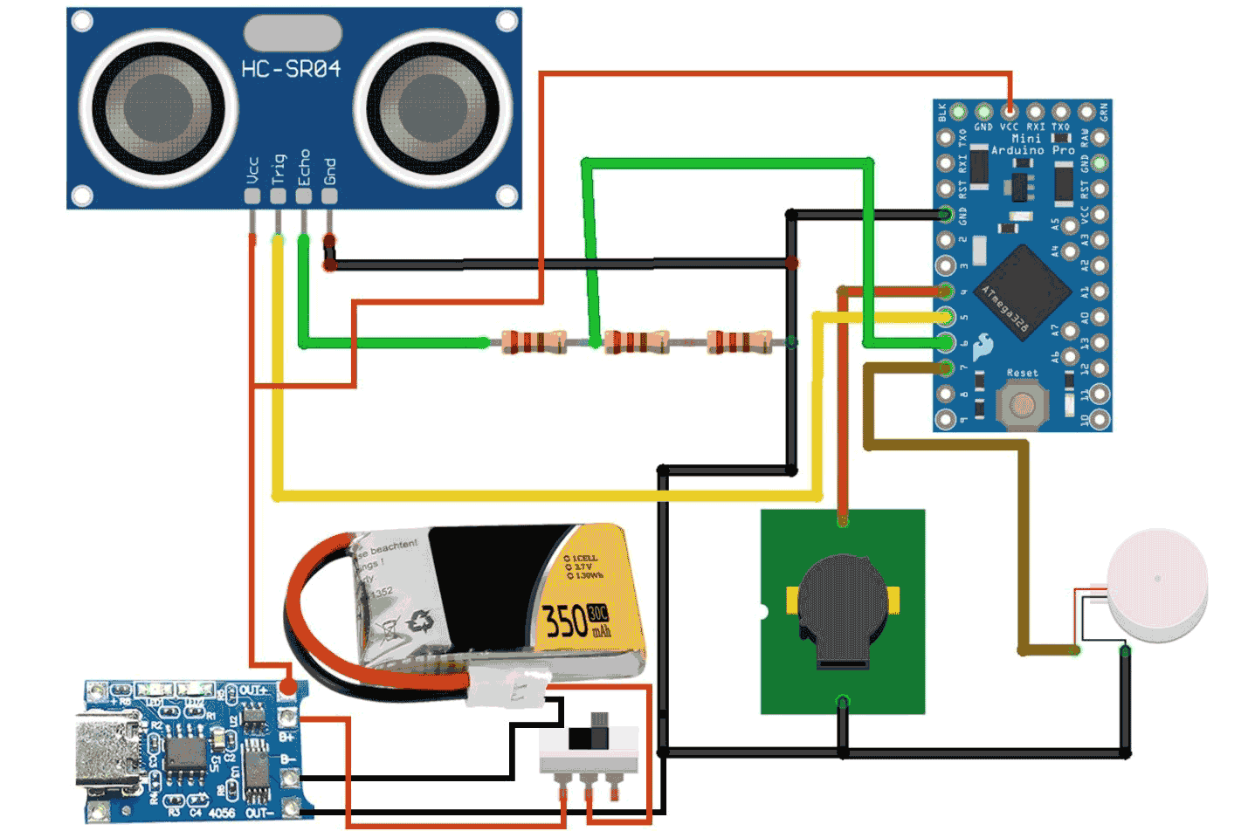

Ultrasonic sensors work on the principle of echolocation. An ultrasonic pulse is emitted from the sensor’s transmitter and the time it takes for the pulse to reflect off an object and return to the receiver is measured. Knowing the speed of sound, this time delay can be used to calculate the distance to the object.
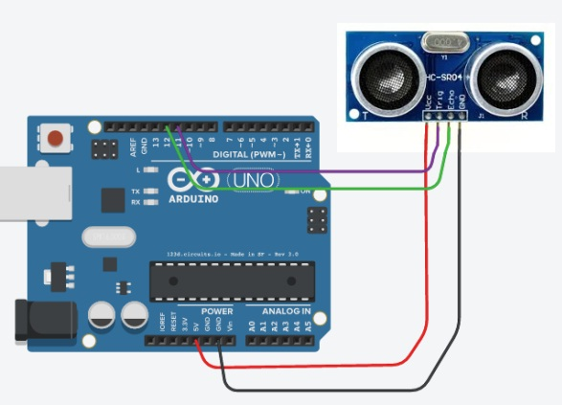

The Smart Blind Stick uses an HC-SR04 sensor which has a detection range of 2-400cm. It operates by sending a trigger signal to initiate a pulse, then measuring the echo return time on the echo pin. This time delay is processed by the Arduino Nano microcontroller to determine the distance.

Distance information is crucial for safe navigation. The controller programs different audio tones based on pre-set distance thresholds to provide early warning. Lower tones indicate obstacles are near while higher tones means something is further away.

Adding tactile feedback through vibration motors provides a second sensory cue. Paired tones and pulses work together to effectively convey proximity information without sight.

By augmenting the ultrasonic sensing technology and microcontroller processing with multimodal alerts, the Smart Blind Stick aims to enhance obstacle detection and navigation ability beyond the limits of the traditional white cane. With appropriate testing and refinement, it has potential to significantly improve independent mobility for the visually impaired.

Equipment:-
Sure! In summary, the equipment needed to build a smart blind stick using Arduino includes:

1_ Arduino board (Arduino Uno.)
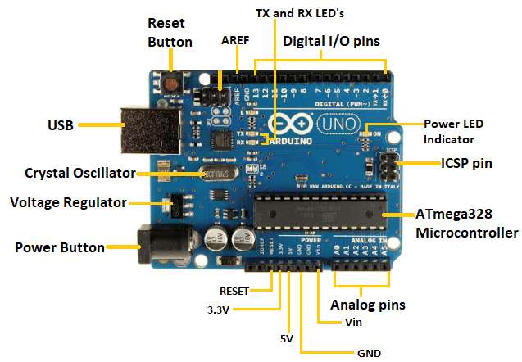

2_ Ultrasonic sensors (e.g., HC-SR04)
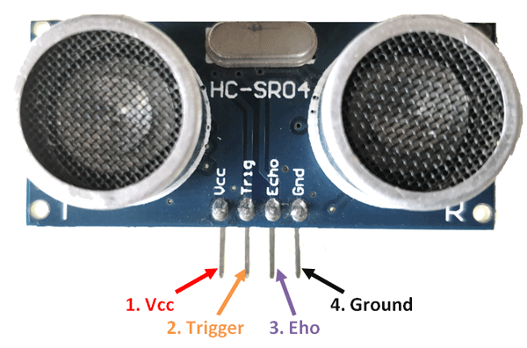

3_ Vibration motors (e.g., Haptic motor.)
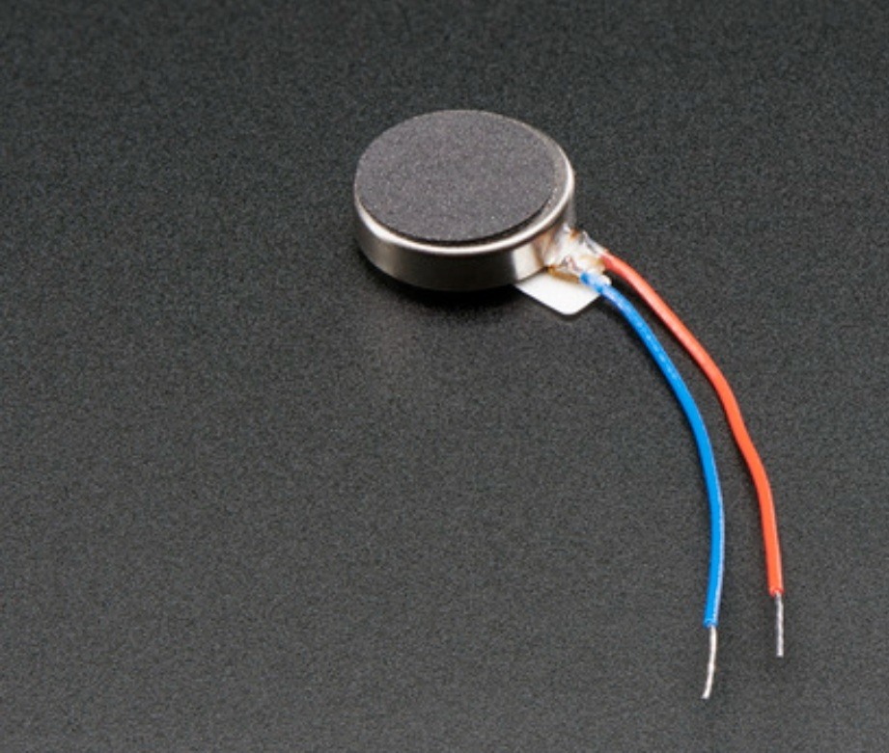

4_ Battery (rechargeable or portable power bank or Lithium ion battery 300MAh 20220117 )
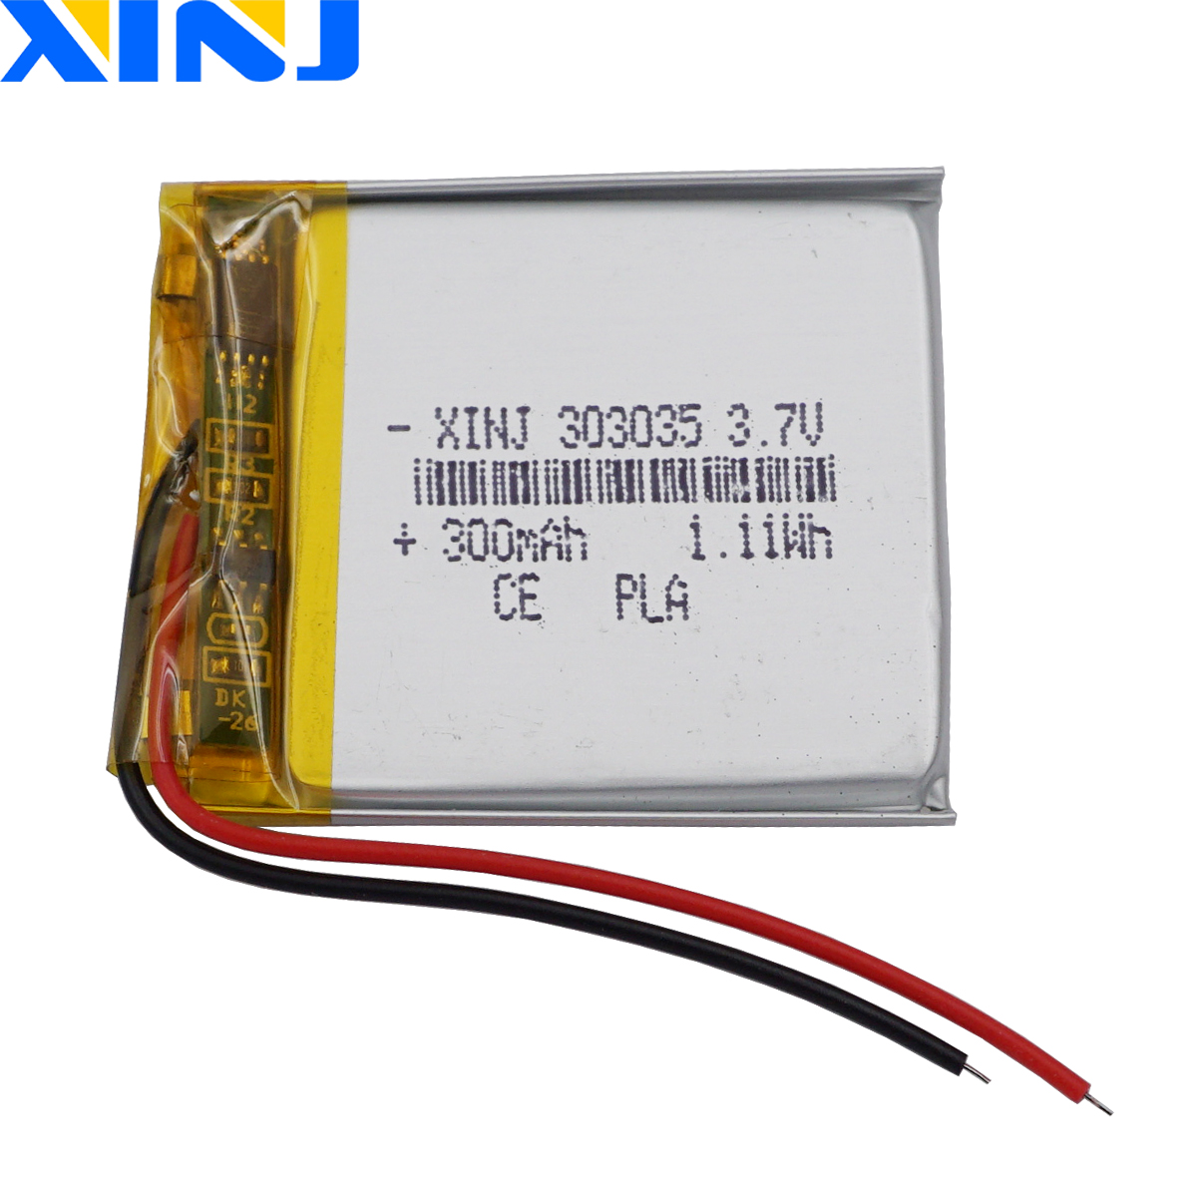

5_ TP4056 Type-c USB
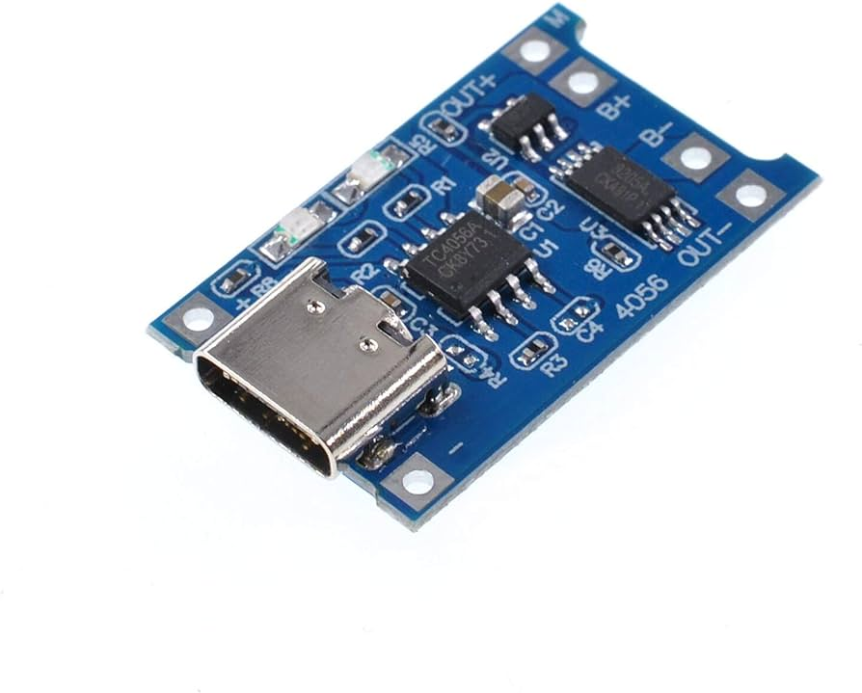

6_ Connecting wires (jumper wires or connecting cables)
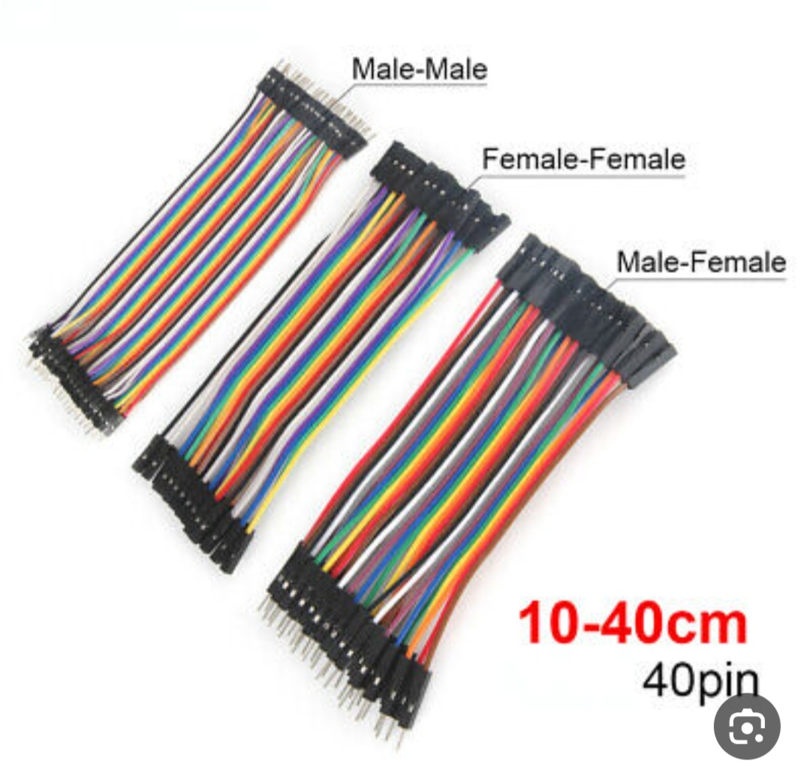

7_. PCB (for prototyping)
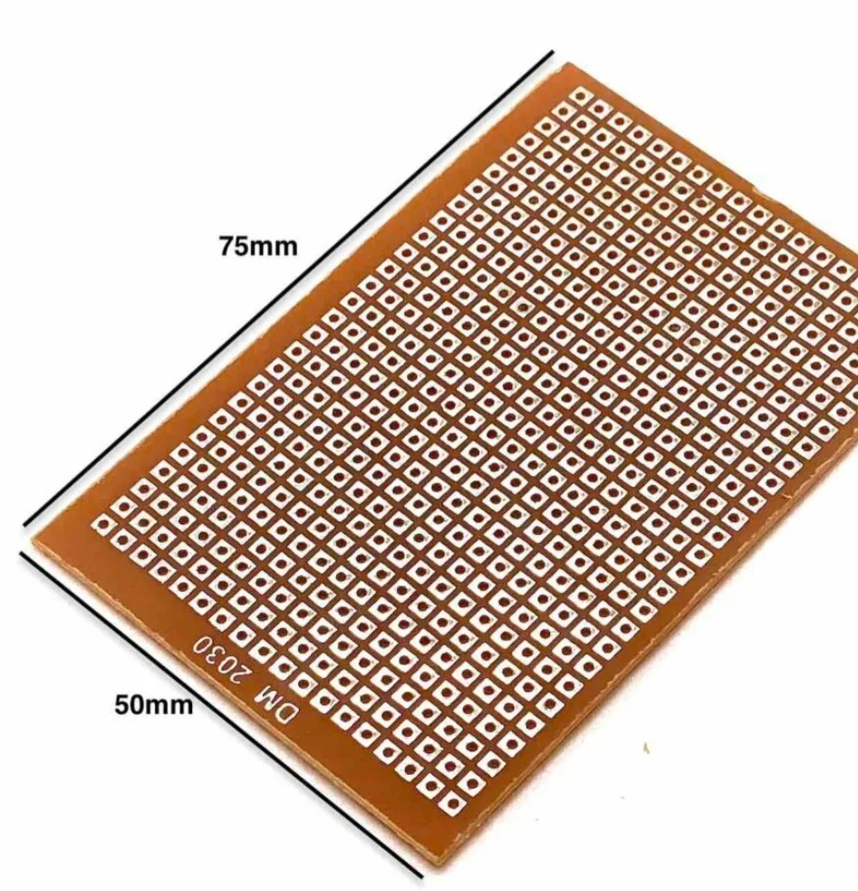

8_ Optional components like switches SPDT, and a buzzer.
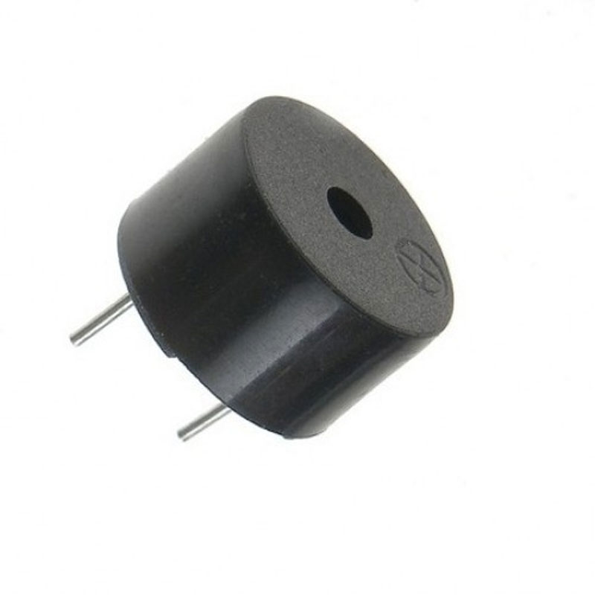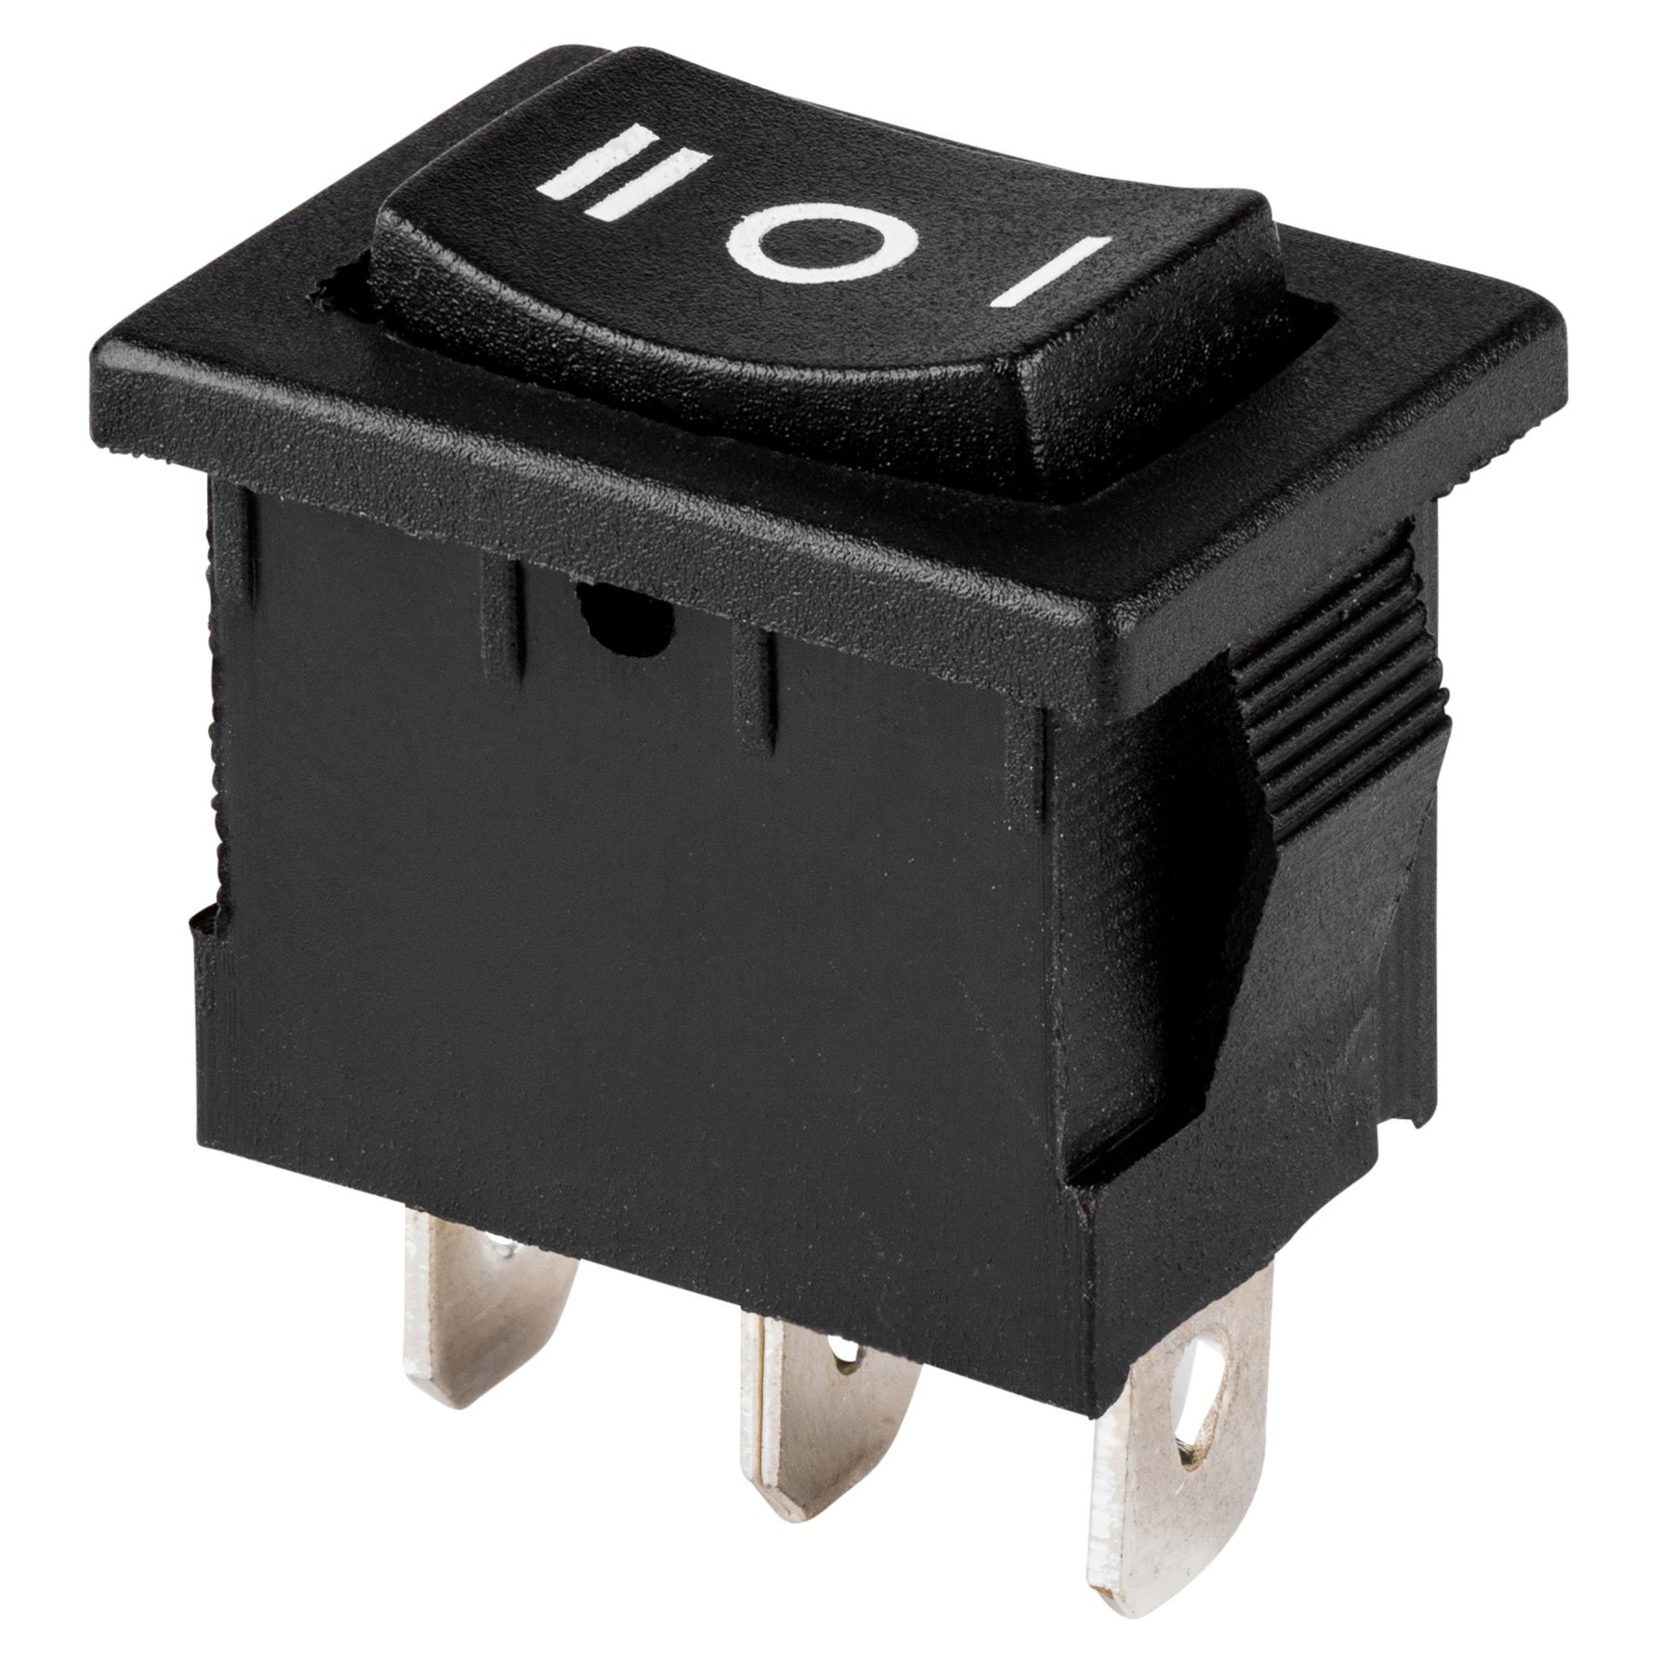

Methodology:
The project will follow the following methodology:

A. Research and Design Phase:
- Conduct a comprehensive review of the currently available technologies for a smart cane and user requirements.
- Analyze the requirements and constraints related to the smart cane.
- Design the mechanical structure, electrical components, and control system architecture for the smart cane.
- Perform computer-enhanced simulation and modeling to verify the design.

B. Prototype Development Phase:
- Secure the necessary components and materials to build the initial prototype of the smart cane.
- Assemble and integrate the mechanical, electrical components, and control system.
- Develop and program navigation algorithms and obstacle detection based on the specified requirements.
- Conduct intensive testing and debugging to ensure proper functionality and reliability.

C. Evaluation and Testing Phase:
- Conduct a series of experiments and tests to evaluate the performance and effectiveness of the initial prototype of the smart cane.
- Gather user feedback and conduct surveys to gather their opinions on the smart cane.
- Analyze the data and identify areas that can be improved and enhanced.
- Improve the design and algorithms based on the evaluation results and user feedback.

Procedure:-
Here is a draft outline of the procedures section for developing a Smart Blind Stick using Arduino:

1. Hardware Components
- Arduino Nano microcontroller
- Ultrasonic distance sensor module (HC-SR04)
- Speaker
- Vibration motors
- Battery
- Extendable pole
- Mounting brackets

2. Circuit Design
- Connect ultrasonic sensor trigger and echo pins to Arduino digital pins
- Connect speaker positive and negative wires to audio pins
- Connect vibration motor wires to Arduino pins
- Add resistors/capacitors as needed

3. Software Design
- Program ultrasonic sensor to initiate reading on trigger pin
- Calculate distance based on echo ping time
- Set audio tone frequencies based on distance thresholds
- Code motor pulses for tactile feedback

4. 3D Printed Housing
- Design housing enclosure in CAD software
- 3D print parts to securely mount components

5. Circuit Assembly
- Solder components onto prototyping board
- Attach board and batteries inside housing

6. Testing and Calibration
- Validate ultrasonic readings at distances
- Test audible tones change appropriately
- Test tactile motors function as coded

7. Field Tests
- Deploy prototype with visually impaired volunteers
- Collect feedback and note any issues
- Iterate design as needed

8. Future Work
- Add directional sensing and navigation abilities
- Integrate with smartphones for mapping
- Conduct expanded multi-user evaluations

Discussion:-
Sure! Here’s the modified discussion with the names Hassan and Jehade:

Hassan: Have you heard about the concept of a smart blind stick using Arduino?

Jehade: Yes, I have! It’s an interesting application of technology to assist visually impaired individuals in their mobility, right?

Hassan: Absolutely! Traditional blind sticks have limitations as they rely on physical contact to detect obstacles. But with a smart blind stick using Arduino, it can detect obstacles using sensors like ultrasonic sensors.

Jehade: That’s impressive! So, the ultrasonic sensors emit sound pulses and measure the time it takes for the pulses to bounce back, right?

Hassan: Exactly! By calculating the time taken, the system can determine the distance to obstacles. If an object is detected within an unsafe range, the Arduino board activates vibration motors to alert the user.

Jehade: That’s a great way to provide feedback to the visually impaired users. I imagine it must greatly enhance their navigation and safety.

Hassan: Yes, it does! And the best part is that the system can be built using readily available hardware components like an Arduino board, ultrasonic sensors, vibration motors, and a battery.

Jehade: That sounds affordable and accessible. I also like that the system can be customized to meet individual needs.

Hassan: Absolutely! The system can be prototyped and tested to ensure accurate obstacle detection. It’s crucial to gather feedback from visually impaired volunteers to make improvements.

Jehade: I can see how this smart blind stick can significantly improve the mobility and independence of visually impaired individuals. It’s a wonderful application of technology.

Hassan: Definitely! However, it’s important to acknowledge the limitations of the system, such as its limited detection range. But there’s room for future work, like incorporating GPS for navigation assistance or adding voice alerts to provide more comprehensive feedback.

Jehade: That’s a great point. Technology is constantly evolving, and these advancements can further enhance the capabilities of the smart blind stick.

Hassan: Indeed! With continued research and development, we can create even more effective solutions to empower visually impaired individuals and improve their quality of life.

Jehade: I’m excited to see how this technology progresses and positively impacts the lives of many people.

Conclusion:-
The smart cane for the visually impaired using Arduino aims to enhance independence and improve the navigation experience for visually impaired individuals by utilizing advanced technologies such as sensors and GPS. The device aims to provide assistance in navigation, improve safety, and offer useful tools for daily life for individuals with visual disabilities.

Reference:- In general, I used the sites provided in the Google application.

Note: I will not include the Global Positioning System (GPS) in the smart cane as it would require significant time, financial resources, and extensive research. It would be physically and mentally exhausting to summarize.

